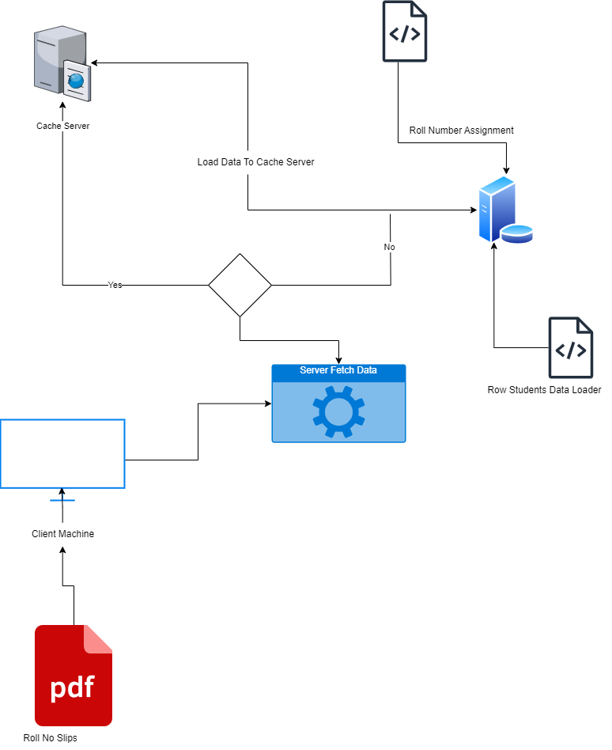**Diagram 1:**

**Diagram 2:**

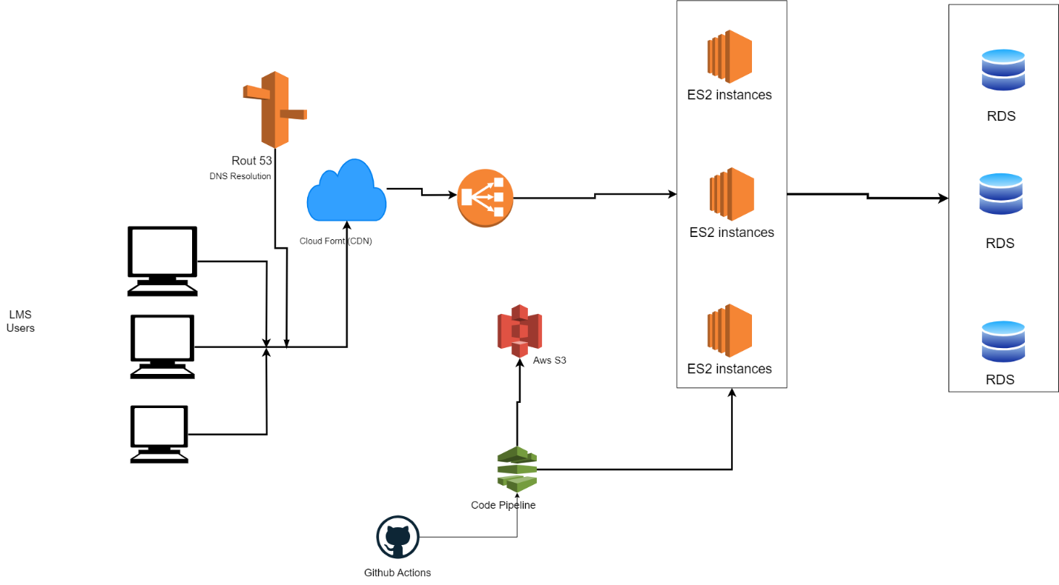

**Diagram 3:**

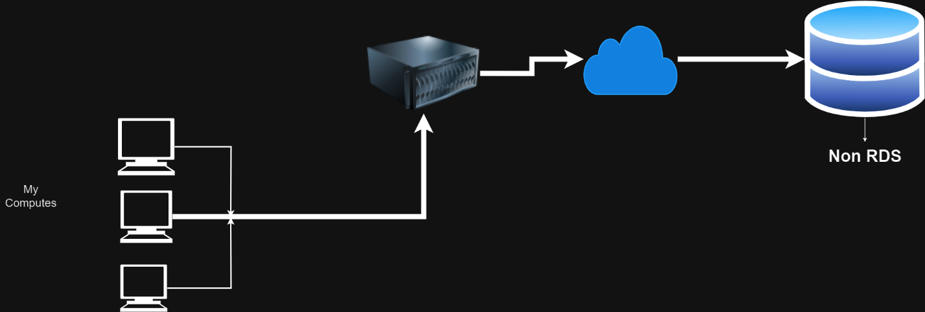

**Part 2:**

1. **Load Balancer:** A load balancer is like a traffic cop for websites, helping to evenly distribute visitors to different servers to keep the site running smoothly.
2. **CDN (Content Delivery Network):** A CDN is a system that makes websites load faster by storing pictures, videos, and other things in lots of places around the world, so it's closer to you when you visit a site.
3. **Rate Limiter: I**t as a speed limit for actions on a website. It stops people or computers from doing too much too quickly, so the website stays safe and fast.
4. **Caching Server:** A caching server is like a super-fast memory that stores things the website needs often. It helps the site load quickly because it doesn't have to fetch the same stuff over and over.
5. **Blue-Green Deployment:** This is a way to update a website without it going down. It's like switching to a new car while the old one is still running.
6. **CI/CD (Continuous Integration/Continuous Deployment):** CI/CD is a fancy way to describe how new features and fixes get added to a website. It's like a team of robots that automatically build, test, and put new stuff on the site.
7. **Firewall:** A firewall is like a security guard for a website. It keeps out bad things and only lets in good things.
8. **Authentication:** Authentication is how a website makes sure you are who you say you are before letting you in. It's like showing your ID to get into a club.
9. **Authorization:** Once you're inside the website, authorization decides what you can and can't do. It's like rules that say who can go where and do what.
10. **JWT (JSON Web Token):** A JWT is like a special code that websites use to remember who you are after you log in. It's like a secret stamp that proves you belong.
11. **Sessions:** Sessions are a way for a website to remember you while you're using it. It's like keeping a tab open at a restaurant. they know you're still there even if you step out for a moment.
12. **Web Socket:** Web Sockets allow a website and your computer to talk to each other very quickly. It's like a super-fast phone line for them to share information in real-time.
13. **Queuing Server:** A queuing server is like a to-do list for a website. It helps the site keep track of tasks and do them one by one, like when you're checking off items on a list.

**Answer the Questions:**

1. **In the scenario of encountering 200,000 concurrent users on your web or mobile project, how would you manage the load, and what technologies would you employ to handle such traffic efficiently?**

* Load Balancer.
* Content Delivery Network (CDN).

1. **While your mobile or web application is live, you need to make updates without causing any downtime. How would you achieve this goal and ensure the site remains operational throughout the update process?**

* CI/CD
* Blue-Green Deployment

1. If your website faces a Distributed Denial of Service (DDoS) attack, describe your strategy for detecting and preventing it effectively. **What tools or techniques would you employ to safeguard your site?**

* Consider a CDN with DDoS protection.
* Use a Web Application Firewall (WAF).

1. **When dealing with unstructured data in your project that needs to be stored in a database, how would you resolve this issue? Which database system would you choose, and what are the reasons behind your selection?**

* Using Non-relational databases e.g. **mongo db**

1. **If your website handles critical transactional data that requires robust security measures, what technology stack would you use, and why? Explain your choice in detail.**

* use old and stable technology e.g. ROR
* use web server technology like Apache

1. **Given an audience spanning Pakistan and the USA, how would you determine the optimal server locations and implement traffic redirection to ensure users are directed to the nearest server based on their location?**

* Use CDN technology.
* Use Cashe server.

1. **When dealing with static data like images, icons, and fonts on your website, how would you optimize the storage and delivery of such content? What technologies or methods would you employ for efficient management?**

* Using CDN technology
* Use Cashe server.

1. **To implement a real-time notification system within your application, what technology stack or method would you choose, and why? Provide a comprehensive explanation of the chosen approach and its advantages.**

* WebSocket.
* Authentication and authorization.